


BSc Hons in Computing
2024.2

A Multi-Modal IOT Diagnostic Framework for Eggshell Micro-Crack Morphology and Root-Cause Analysis in Poultry Breeder Farms

Coventry Index : 16110429
NIBM Registered Name : M.P.N. Sharindi

Faculty of Engineering, Environment and Computing
School of Computing, Electronics and Mathematics
Coventry University

School of Computing and Engineering
National Institute of Business Management

Table of Contents

Table of Contents ii
List of Figures ii
Chapter 1: Introduction 1
1.1 Background 1
1.2 Research Problem 1
1.3 Objectives of the Project 2
1.4 Research Questions 2
1.5 Scope of the Research 3
1.6 Chapter Conclusion 4
Chapter 2: Literature Review 5
2.1 Findings by other Researchers 5
2.2 The Research Gap 6
2.3 Chapter Conclusion 6
Chapter 3: Methodology 7
List of References 8
Appendices 9
Appendix A: Progress Monitoring Sheet 9

List of Figures
Figure 1 : Generalized operational workflow of a poultry breeder farm 4

Chapter 1: Introduction
This chapter presents a basis for the development of an Automated Eggshell Quality Control System in poultry breeding operations. It describes the background context, identifies the main research problem (Critical) for diagnostic purposes, outlines the major goals of the study with corresponding research question(s) and scope of the research design.

1.1 Background
The poultry-breeding industry depends heavily on keeping their hatchability rates high and that is primarily based on the integrity of the eggshell. The presence of micro-cracks (that are typically not visible to the naked eye when looking at eggs during routine inspection, eggs selection process) provides an extremely serious biological concern, as they will significantly speed up moisture evaporating from an egg, increase the risk of bacterial contamination of an egg and increase the level of embryonic mortality dramatically (Khabisi et al., 2012). In the past, the industry used to rely on manual candling inspection or the use of basic mechanical tests to identify these physical defects in the shells of eggs; however, new technologies such as machine vision and the IoT have recently been developed that can enable the automation of quality assessment and monitoring of the poultry production environment (Wu et al., 2025). In addition, the use of Edge-AI with IoT sensor networks has successfully demonstrated the ability to collect real-time environmental data in order to proactively manage the stressors that poultry experience inside barns (Rekiek et al., 2023). Despite these advancements in technology, visual quality assessment of eggs and monitoring of the production environment using IoT are typically done separately and there exists a significant disconnect between detecting a physical defect in an eggshell and understanding the farm conditions that caused that defect.

Research Problem
Automated defect detection has evolved considerably; however, existing tools for defect detection in the poultry space have limited diagnostic capabilities. Currently, visual inspection systems only classify eggs either intact or damaged, but fail to characterize the morphology of individual defects (Cengel et al., 2025). For example, while deep learning algorithms like YOLOv8 can effectively classify cracked eggs with high accuracy within applied environments, they are incapable of determining whether the crack occurred from traumatic impact due to a mechanical force versus from nutritional deficiencies resulting in a fine crack (Cheng et al., 2024). As a result, farm operators will receive rejection metrics, but do not have access to the intelligence that would enable them to understand what led to the defect occurring. Without a system to relate specific visual morphology of the micro-crack to biological meta data (such as the age class of the breeder), farm management cannot trace defects back to their environmental or nutritional causal factors and will be greatly limited in their ability to conduct effective corrective actions.

Objectives of the Project
- To identify micro cracks and classifying various micro crack morphologies through the use of a multi-model ML framework.
- To determine the probable causes of detected defects separately identifying between nutritional (physiological) and environmental (mechanical) factors by combining visual data patterns with biological meta-data (such as breeder age).
- To create an Internet of Things (IoT) based image system, with transillumination (candling) light source, to take high-resolution photographs of eggshells at the very edge.
- To assess the usability and effectiveness of the final Streamlit application as a decision support tool to poultry producers by means of a structured assessment with poultry production managers.

Research Questions
- How can identify micro cracks and classifying various micro crack morphologies through the use of a multi-model ML framework?
- What are the specific root causes of detected defects separately identifying between nutritional (physiological) and environmental (mechanical) factors by combining visual data patterns with biological meta-data (such as breeder age)?
- How can create an Internet of Things (IoT) based image system, with transillumination (candling) light source, to take high-resolution photographs of eggshells at the very edge in an operational farm environment?
- What is the level of the usability and effectiveness of the final Streamlit application as a decision support tool to poultry producers by means of a structured assessment with poultry production managers?

Scope of the Research
Research focused on elements of software engineering, machine learning and data analysis for poultry farm quality control. The final application uses high-resolution images taken of eggshells and biological metadata (breeder age class, etc.) as input. The multi-modal deep learning model is responsible for performing two functions: 1) foundational image classification (binary classification of defects), and 2) image analysis of crack morphology using visual (heatmap) diagnostic analytics. This model correlates the respective defect patterns in the image with the provided metadata in order to establish whether the crack originated from an environmental challenge or nutritional deficiency. The results are provided to the user via an intuitive, easy-to-use decision support application, which displays:
- defect classification
- morphological pattern
- targeted, actionable feedback to the farm manager
To illustrate where these systems fit into the larger context of the poultry industry, see Figure 1 for a high-level view of the poultry breeder farm system's operational workflow.
There are defined limitations of the study to consider. Data on the industry flock will provide information needed to verify operational data/statistics and will be maintained as confidential by ensuring all operational values/measurements and performance measures are pseudonymized, protected or converted to a derived indicator. In addition to maintaining the security of company names, the physical boundaries will not include the mechanical engineering/construction of large automated farm conveyor systems or automated farm systems to develop and test IoT imaging edge device and software analytics.
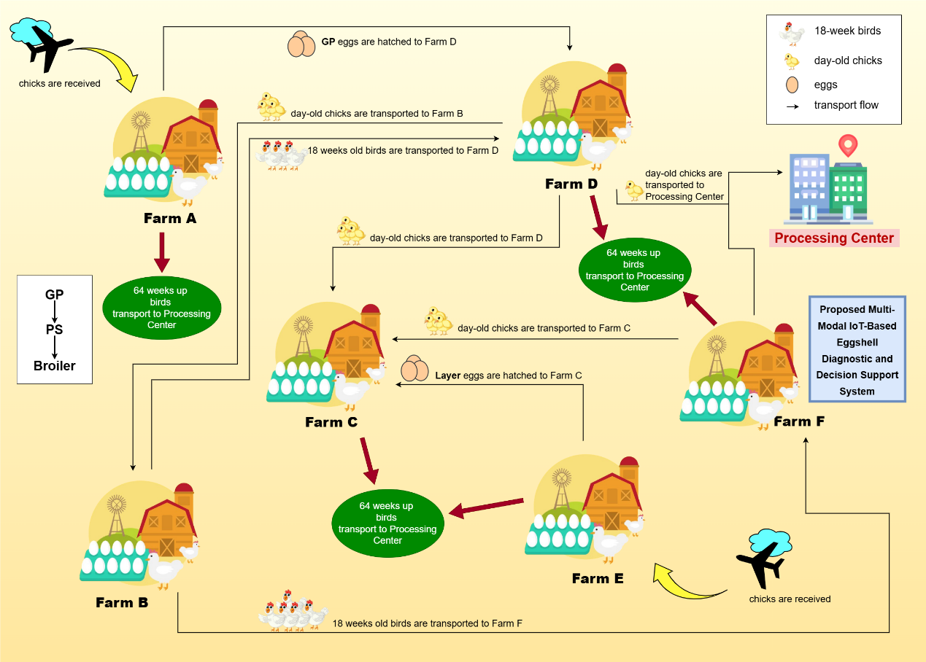
Figure 1 : Generalized operational workflow of a poultry breeder farm

Chapter Conclusion
In conclusion, the chapter has outlined the context and importance of the study of poultry breeding. The limitations of the current automatic egg inspection system was illustrated with the inability of current automatic systems to provide detailed morphology and to identify causes of defects in the shell of the egg. Therefore, to meet the needs of the industry, the study has defined objectives and generated research questions that are measurable with the hope of creating a multi-modal IoT diagnostic framework to alleviate this situation. The chapter also emphasized the guidelines for ethical protection of human resources, as well as providing an illustration of the workflow of the proposed system. Finally, the next chapter will analyze existing literature in an effort to validate the research gaps identified.

Chapter 2: Literature Review
This research will create an IoT multi-model diagnostic framework to detect micro-cracks in the eggshells and to determine the underlying cause of micro-crack formation through morphological methods. To begin this research, it is essential to review currently available technologies. Currently, recent literature of the poultry industry (management, quality control, etc.) has made significant advancements since the inception of simplistic IoT Environmental Monitoring Systems to advanced computer vision-based applications to identify physical defects. However, the reviewed literature suggests a significant discrepancy between identifying a defect and determining the cause of the defect.

2.1 Findings by other Researchers
Initial research into the use of edge computing and the Internet of Things (IoT) within poultry farming placed a strong emphasis on the tracking and monitoring of environmental conditions. For example, Rekiek et al. (2023) studied the effectiveness of combining edge artificial intelligence and IoT sensor networks to predict poultry stressors and evaluate the concentrations of harmful gases found inside poultry barns. In doing so, they demonstrated that-edge computing could be utilized to process large amounts of agricultural information in real time; however, their study was limited to evaluating atmospheric data and did not relate the assessment of any environmental conditions to the quality of physical outputs, such as eggshell integrity. With the maturation of artificial intelligence, the next step was for researchers to use computer vision as a means of directly assessing quality. Cheng et al. (2024) examined the difficulties of identifying damaged eggs in changing industrial settings by applying YOLO designs to multi-domain training techniques to accomplish an 88.8% mean average precision (MAP). This study provided compelling evidence of the efficacy of deep learning frameworks for rapid deployment at the edges, but the only output from this system was the identification of the existence of the crack and not any diagnostic detail about the nature of the underlying defect. More recently, Cengel et al. (2025) improved the accuracy of these automated visual inspections by using Convolutional Neural Network (CNN) framework to produce an accuracy measurement of 98.73% for classification of a fully labelled dataset of healthy and damaged eggs, thus establishing additional credibility for the ability of CNNs to effectively replace manual candling as a method of identifying defects on the surface of an egg. The limitation of both these studies was the development of frameworks for only binary “pass fail” classifications and were completely agnostic to the biological basis of the egg being considered.

The Research Gap
There is a considerable gap in research at the junction of visual inspection and biological diagnosis, despite substantial strides in environment tracking (Rekiek et al., 2023) to highly accurate visual classification (Cengel et al., 2025; Cheng et al., 2024) by chronological advancement. Current machine-learning algorithms (model) restrict themselves to a simple "Intact/Damaged" classification (binary classification) with no options for morphological analysis that would include some evaluation of the structural form and pattern of the crack (e.g., distinguishing between a localized star-crack from a mechanical impact or a spider web type hairline crack that would indicate the physiological thinning of a shell). In addition, existing computer vision models also evaluate the eggs in a vacuum, and do not take into consideration critical biological metadata (most importantly, the breeder's age class) which will have a direct impact on the deposition of shell calcium (Ca) onto the eggs. Alternatively, while most current IoT systems do a good job of tracking farm environments, they offer no way of connecting the environmental information to the physical morphology of an eggshell. Therefore, there is no current decision-support system available for diagnosing either a nutritional deficiency or an environmental stressor when a microcrack is detected.

Chapter Conclusion
The combination of Edge-IoT and DL has independently demonstrated their efficiency as two technologies that have helped to change the way poultry farms operate. However, the current implementations of these technologies do not produce comprehensive, root-cause diagnostic information related to eggshell defects. The previous chapter presented a historical progression (or chronological evolution) of these technologies and identified two key areas that are missing from current implementations. First, morphological analysis is lacking from the current technologies and secondly, metadata integration between edge and cloud computing (i.e., IoT devices) is non-existent. Addressing this gap will provide managers of poultry farms with a means of gaining to produce comprehensive, actionable intelligence regarding farm operations through a proposed research framework.

Chapter 3: Methodology
An applied quantitative methodological approach has been employed in this research study with an emphasis on creating, integrating, and evaluating a unique software and IoT device designed to enable poultry farm managers to make more informed decisions regarding their operations.
Data collected in the present study consists of high-quality domain-specific data regarding eggshell images captured with a proposed IoT imaging device with transillumination (candling) lighting, which can reveal non-visible subsurface micro-cracks present on egg surfaces. In addition to the egg image data described above, biological metadata such as breeder age class and flock profile will also be collected from a collaborating organization; however, as required by ethical conduct guidelines established by the collaborating organization, all flock operational data will be transformed, normalized, or masked in order to fully anonymize the data and maintain confidentiality of the data contained within this study.
The proposed research study will utilize a multi-mode/multi-modal machine learning methodology, rather than a simple binary classification. To create visual diagnostic analytics, such as identifying crack shapes through heat maps, we will adapt previous studies by Cengel et al. (2025) to use Convolutional Neural Network (CNN) architecture as a basis for developing algorithms that will identify the underlying cause of crack formation. In addition to using CNN architecture to identify cracks based on visual characteristics, we will also fuse the results of visual analysis with anonymized biological metadata, allowing the algorithm to distinguish between crack-causing environmental stress (mechanical) and nutritional deficiency (physiological) as the root cause of defects.
All of this information, will be displayed using a Streamlit based dashboard application. The innovative features of the diagnostic system will then be rigorously evaluated. The machine learning component will be quantified via validation data, which will determine the model's accuracy, precision, recall, and F1 scores to demonstrate robustness (Cheng et al., 2024). Lastly, we will also evaluate the diagnostic system's practical effectiveness through structured usability surveys and user acceptance testing (UAT) with poultry farm managers to confirm that the root cause insights provided by the dashboard will assist with operational decision making.

List of References
Ahmed, M. W., Alam, S., Alin Khaliduzzaman, Emmert, J. L., & Kamruzzaman, M. (2025). Non‐destructive measurement of eggshell strength using NIR spectroscopy and explainable artificial intelligence. Journal of the Science of Food and Agriculture. https://doi.org/10.1002/jsfa.14290
A Çelik, & Tekin, E. (2024). Classification of Hatchery Eggs Using a Machine Learning Algorithm Based on Image Processing Methods: A Comparative Study. Brazilian Journal of Poultry Science, 26(2). https://doi.org/10.1590/1806-9061-2023-1882
Cengel, T. A., Gencturk, B., Yasin, E. T., Yildiz, M. B., Cinar, I., & Koklu, M. (2025). Automating egg damage detection for improved quality control in the food industry using deep learning. Journal of Food Science, 90(1), e17553. https://doi.org/10.1111/1750-3841.17553
Cheng, Y., Huang, Y., Zhang, J., Zhang, X., Wang, Q., & Fan, W. (2024). Robust Detection of Cracked Eggs Using a Multi-Domain Training Method for Practical Egg Production. Foods, 13(15), 2313. https://doi.org/10.3390/foods13152313
Castro Júnior, S. L. de, Cândido, A. E. C. M., Silva, A. C. de S., & da Silva, I. J. O. (2025). Translucency of chicken eggs: proposal of an automated system for analysis and classification. Poultry Science, 104(10), 105612. https://doi.org/10.1016/j.psj.2025.105612
Hamadani, H., Hamadani, A., Boje, P. H., Moyon, A., & Khan, A. A. (2025). Enhancing Egg Grading Precision through AI and Computer Vision-Powered Morphometric Analysis. https://doi.org/10.21203/rs.3.rs-6016705/v1
KHABISI, M. M., SALAHI, A., & MOUSAVI, S. N. (2012). The influence of egg shell crack types on hatchability and chick quality. Turkish Journal of Veterinary & Animal Sciences. https://doi.org/10.3906/vet-1103-20
Hakim Jebari, Meriem Hayani Mechkouri, Siham Rekiek, & Kamal Reklaoui. (2023). Poultry-Edge-AI-IoT System for Real-Time Monitoring and Predicting by Using Artificial Intelligence. International Journal of Interactive Mobile Technologies, 17(12), 149–170. https://doi.org/10.3991/ijim.v17i12.38095
Wu, Z., Zhang, H., & Fang, C. (2024). Research on machine vision online monitoring system for egg production and quality in cage environment. Poultry Science, 104(1), 104552. https://doi.org/10.1016/j.psj.2024.104552
Yu, P., Shen, C., Cheng, J., Yin, X., Liu, C., & Yu, Z. (2025). Advances in Nondestructive Technologies for External Eggshell Quality Evaluation. Sensors, 25(18), 5796. https://doi.org/10.3390/s25185796

Appendices

Appendix A: Progress Monitoring Sheet

